Identifying the health of fetal using Cardiotocography (CTG) data (CE880: Case Study)
*Note: Sub-titles are not captured in Xplore and should not be used

Mr. Jabbar
Student of University Essex

Abstract—the study aim is to design the machine learning classification method in which produce the CTG dataset to identify the women fetal and fertility rate and child labor rate. The main contribution to solve the cross over between the normal and suspicious class problem in antepartum dataset based on various values which taken from university site, SVM and KNN classifier used in this research with great F1 score and precision recall score. The performance data modeling has been analyzed by predicted the dataset on exploratory data analysis which is very useful information to view the diagram view of the dataset and numerical statistical information also used to validate and predict the dataset point value. Intelligence machine learning classification method has been proposed to design the system architecture of CTG data which proposed on different ratio value. Since the deep forest algorithm does not produce the high-quality result comparative to the support vector machine classifier algorithm and KNN algorithm also very useful method to predict and validate the disease of heart rate value. Data preprocessing
Keywords—Fetal rake, Risk of fetal, Machine learning, (key words)

Introduction
Machine learning programming enable this research to predict and validate the outcomes of research to evaluate the necessary action to be taken to validate the fertility prediction of women which gives birth and might be the during delivery the fetus lost. This research investigates the dataset of fertility in which the variable used to estimate the support vector machine classifier and KNN classifier in python. The target variable predicts the binary classification 0 and 1 which means fertility is present in 1 and not present in 0 class. Medical diagnosis is prediction which closely related to health of women and machine learning electronic health prediction validate the true outcome which nearest to the reality and very close the disease prediction. This research objectives to analyze clinical trial dataset and support them by analyzing though machine learning prediction classification technique. The fetal cognitive anomalies besides the traditional pregnancy test using the machine learning method which support e-health applications. In this research we developed KNN and SVM classifier by target the diagnose variable and make prediction based on the training and testing features of the dataset. The practioner and pregnant women can make use this research to minimize the pregnancy disorder.

Prediction of Fetal Risk

Background
[1] the major contributor to estimate the under five mortality features the death of children under first month of life. Intrapartum problems are the main reasons of perinatal mortality, since the Fetal cardio graphic could be used as tool to diagnose and monitor the women high risk during the pregnancy labor.

Aim & Methods
The objectives of this research are going to present the precision of machine learning features by featuring the SVM and KNN classifier algorithm in which the target research variable has been analyzed from the dataset. The CTG data of 2126 pregnant women were obtained from the University of Essex. The sensitive precision and F1 score machine learning classifier obtained the correct way to analyzed the fertility rate. The accuracy of each model was trained using the CTG by identifying them in order to predict the normal suspect and pathological fetal state and the ML best performance has been discussed.

Literature Review (Background)

Fetal Risk using bagging Ensember Classifier
Cardiograph utilized to analyze the [2] monitoring the fetal status of pregnant women during the period of postpartum and antepartum with intrapartum period the condition of fetal might be best monitored and analyzed them since the pregnant women was major issue to monitor the health of the women, the predictions are assessed in real time clinical decision has been made to analyze the working of the risk of fetal asteroids. The improved and robust machine learning approach has been used in the past to analyze the fetal risk and birth rate risk. The women abnormal behavior has also been analyzed. The accuracy of F-Measure score with ROC area utilized in performance metrics to assess the success of classification bagging ensemble to present the high-quality outcomes with accuracy score of 99%.

Quantitative Assessment of Fetal well being
- The parameter based rectifying signal based on average value since the CTG technique widely used by various [3] researcher in the past recording the fetal heart rate signal including uterine contractions and its interpretation usually performed through the inspection by trained obstacle workers, to minimize the interobserver variability, the parameter of computer fertility heart rate predicted based on the dataset value, novel parameter computed in series based phase identify the signal average curve slope rectified has been identified and validated the novel approach identify the phase rectified average curve depend on the slope signal in order to test and validate the heart rate and beat rate between the restricted features of viable variability, the outcome suggest the early fetal diagnose.
- [4] fetal state classification method using the machine learning approach which examines the major problems and its reason in the pregnant women the condition of fetus inside womb are not appropriate, and the major chance of health well being predicted on the early stage of fetal and fetus alive and it has been rectify based on the women condition and its previous report which includes clinical trial dataset. This research present the machine learning algorithm which analyze them fetal heart rate, uterine contraction in both direction and uses the machine learning decision tree, support vector and naïve bays classifier to predict and analyze the dataset and present the different classification report outcomes and F1 score, the score has been compared as well on the system recall section and average rate score of fetal has been monitored with classification technique.
- [5] system prediction and noise suppression from intra partum and post-partum during the labor in normal fuses condition of the women analyzed using the machine learning approach since the linear system identification model getting though with noise suppression with pseudo inverse method the ability to identify the decimation approach of hypnoses defuses of fetus alive with normal condition or abandoned condition. The average model features have been used the SVM classifier which applying the pseudo inverse method in which various factor has been analyzed and predicted based on the lower variance accounted reduced overfitting receiver character operator which featured the results.
- [6] the relationship between fetal heart rate including parameter of cardiograph by employing the multi classification method, since the CTG track the heart movement including detect its positive and negative feature and time line. Since the comprehensive rate of decision support system needs to ensure the symptoms of disease which cause pregnancy failure chances, clinical decision support system focuses on discovering the data mining extraction and feature detection method associated with rule mining method which get the CTG properties in accordance of CTG and ARM data. The target dataset hypothesis has been taken to predict the numerical properties of CTG since the multi objectives evolutionary methods of CTG data which automatically detect the modern MOGA air including rules miners’ approach.
Identify applicable funding agency here. If none, delete this text box.

Total Fertality Rate
Sum of age specific women over their reproductive span period during the child birth condition from its 49 years of age by given the year of observed fertility period.
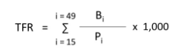
B= total number of live birth registered during the year to meet the mothers of age where I is an interval of one year.
P = midyear female popular in the same age group.

Gross reproduction Rate
- The special case of total fertaility rate observed based on the value of numerator of GPR based on the female birth instead of total birth since the rate is considered based on the demographic theory as it shows in the level of concerned mortality rate and fertility rate of average birth rate of children.

- The number of female infant born at the time of survival through children bearing period then 3 female give birth to child in order to minimize them.
- Child women ratio has also been predicted based on the experienced clinical trial.
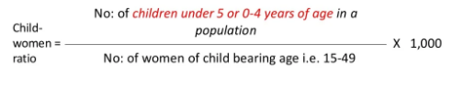

Methdology

The research methods based on machine learning which based SVM classifier and KNN classifier method.

Dataset information

Dataset downloaded from university site based on the following attributes and values to predict the health fetal using the cardiography dataset.

The dataset based on women fertailiyt heart rate which used to predict the average fertaility rate during the labor and pregenency condition.

Identify the attribute of dataset
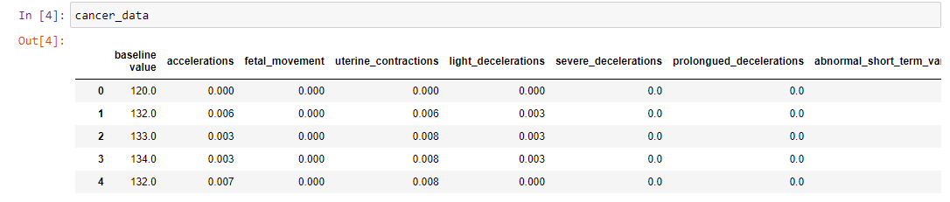
The following attributes shown in the image which taken from the python notebook present the notation of attribute of the dataset.

Data preprocessing
Data cleaning by using the python programing to remove the NA and blank value.

Exploratory data analysis
Data analysis using the statistical method to analyze the dataset by predicting the values based on the conditional parameter of the statistics value.

Dataset describes.

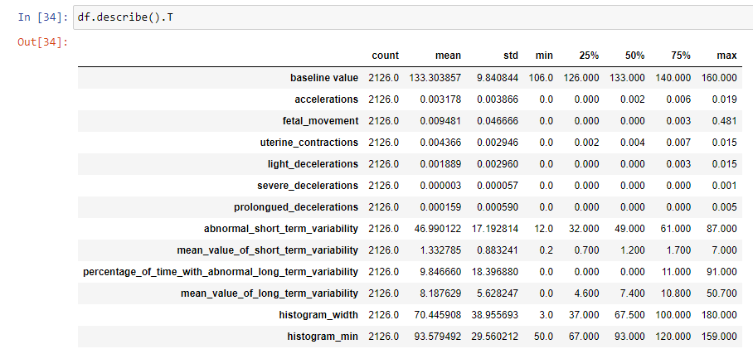

Bivariate data analysis
SNS library in python provides the feature engineering analysis of text by targeting the variable and its featured value.

The plot provides the understanding of radius worst and density parameter

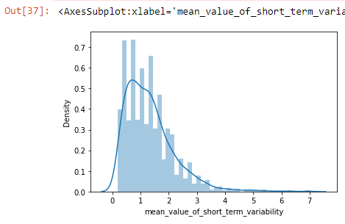

Multivariate data analysis

The multivariate data analysis explored by using the mean of dataset to predict the disease causes and problem in systematic approach.

The histogram of different attributes which getting the useful information by analyzing them.

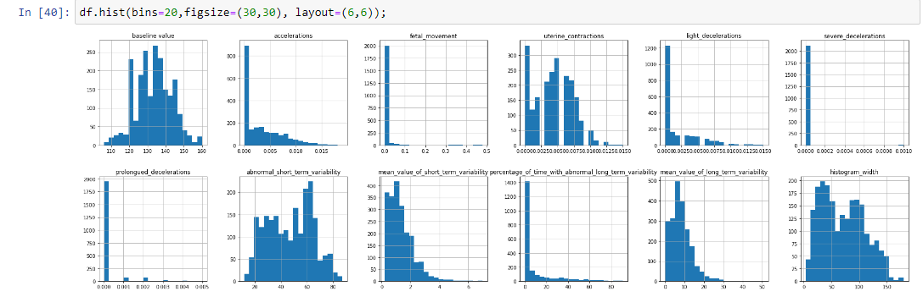

Correlation between different attribute

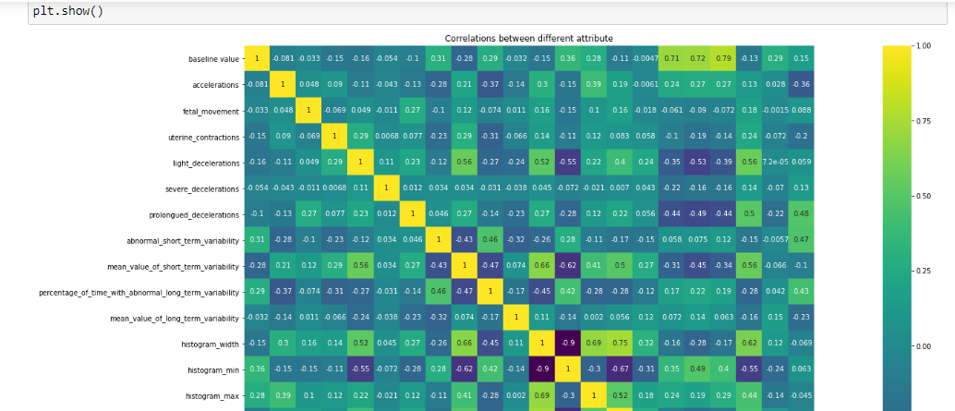
training & testing the dataset
Since the dataset has been train and testing by splitting the values into 2 portion and building the machine learning modeling. Since the machine learning modeling deploy to predict and analyze the feature value of dataset by target them into two variable X and y variable.

Results

Results of this research ahs been produced by taking the machine learning analysis such as in systematic programming approach.

KNN Classifier
Since the KNN classifier used to analyze them both the predicted values of the target variable in order to optimize the result with different classification technique.

KNN classification score
The classification score estimated on 48% value of the estimated result.

KNeighborsClassifier Algorithm is predicted at 29.153605015673982

SVM classifier
Support vector machine classifier result has been obtained by training the dataset and testing the dataset based on the valid values of the variable.

SVM Algorithm is predicted at 27.11598746081505

KNN Classificaton report

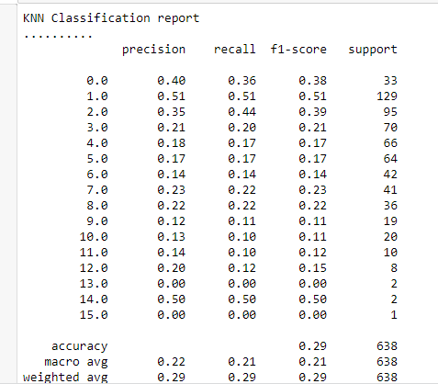

SVM Classification report

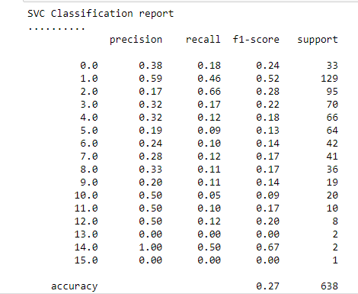

Discussion

[7] fetal health status automatically detection by using the real time machine learning classifier at clinical system. CTG dataset used by mean of machine learning classifier which produces the high-quality outcomes. Computer based machine learning algorithm has been determined the CTG attribute of the dataset and produces the accurate F1 score result with good precision recall method. Since the machine learning computational method containing normal suspected and pathological data available at University site. The machine learning exploratory data analysis has been analyzed with different classification technique and also analyze the value of multivariable data analysis and systematic analysis since the method of support vector machine classifier produce the better accuracy rate comparative to decision tree, logistic regression method. Since the gradian boosted algorithm getting the score of 96% [8] diagnosing the major contribution factor of dataset value which validated the outcomes based on the CTG measurement classification method. Since the fetal heart ratee predicted based on the values of the dataset and analyzed them in different machine learning algorithm. Fetal heart rate monitoring produces the inter partum and post-partum method detection technique in which the order of pregnancy of loss has been minimize them. [9] intelligent classification method proposed on antepartum cardiograph dataset model based on deep learning forest method.

Conclusion
KNN and SVM classifier predict the best result beside this decision tree contain low accuracy score, the fertility count and mean value has been predicted in accurate manner so it is suggested that machine learning supporting in e-health and also plan the guideline based method to minimize the child loss rate in the UK region.

References

- Hoodbhoy, Z., Noman, M., Shafique, A., Nasim, A., Chowdhury, D. and Hasan, B., 2019. Use of machine learning algorithms for prediction of fetal risk using cardiotocographic data. International Journal of Applied and Basic Medical Research, 9(4), p.226.
- Subasi, A., Kadasa, B. and Kremic, E., 2020. Classification of the cardiotocogram data for anticipation of fetal risks using bagging ensemble classifier. Procedia Computer Science, 168, pp.34-39.
- Fanelli, A., Magenes, G., Campanile, M. and Signorini, M.G., 2013. Quantitative assessment of fetal well-being through CTG recordings: a new parameter based on phase-rectified signal average. IEEE Journal of Biomedical and Health Informatics, 17(5), pp.959-966.
- Agrawal, K. and Mohan, H., 2019, January. Cardiotocography analysis for fetal state classification using machine learning algorithms. In 2019 International Conference on Computer Communication and Informatics (ICCCI) (pp. 1-6). IEEE.
- Warrick, P.A., Kearney, R.E., Precup, D. and Hamilton, E.F., 2006, September. System-Identification noise suppression for intra-partum cardiotocography to discriminate normal and hypoxic fetuses. In 2006 Computers in Cardiology (pp. 937-940). IEEE.
- Piri, J., Mohapatra, P. and Dey, R., 2022. Investigating association relationship between fetal heart rate parameters from cardiotocography employing multi-objective evolutionary algorithms. International Journal of Information Technology, pp.1-13. M. Young, The Technical Writer’s Handbook. Mill Valley, CA: University Science, 1989.
- Rayhana, M.T., Arefina, A.S. and Chowdhury, S.A., 2021. Automatic detection of fetal health status from cardiotocography data using machine learning algorithms. Journal of Bangladesh Academy of Sciences, 45(2), pp.155-167.
- Dwivedi, P., Khan, A.A., Mugde, S. and Sharma, G., 2021, July. Diagnosing the major contributing factors in the classification of the fetal health status using cardiotocography measurements: An AutoML and XAI approach. In 2021 13th International Conference on Electronics, Computers and Artificial Intelligence (ECAI) (pp. 1-6). IEEE.
- Chen, Y., Guo, A., Chen, Q., Quan, B., Liu, G., Li, L., Hong, J., Wei, H. and Hao, Z., 2021. Intelligent classification of antepartum cardiotocography model based on deep forest. Biomedical Signal Processing and Control, 67, p.102555.

